Decathlon 20-30CC

Wing Span: 86"(2180mm)
Length: 61"(1550mm)
Wing Area: 1147sq in(74sq .dm.)
Flying Weight: 11-13.5lbs(5000-6100g)
Engine:.70-.91（2C） .91-.110（4C） 20-30cc gas

Electric Power：
KUZA EXM4130-350KV with 8S 3700-4400 mAh 18x10 prop
KUZA EXM5420-280KV with 8S 3700-4400 mAh 18x10 prop
Hacker A50-16S with 6S 3800-4400mAh 18x8 prop
DUSKY XM5060EA-470KV with 6S 4000-5000 mAh 17x8 prop
DUSKY XM6350EA-280KV with 8S 3700-4400 mAh 18x8 prop
Or other 1500-2000Watt electric motor
ESC：80-100A

RADIO:4CH/4-6S

Features:
Newly designed structure
Two pieces removable wings

New Dual Fiberglass horn assembly
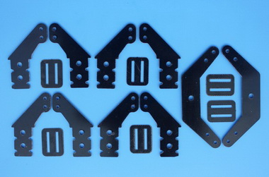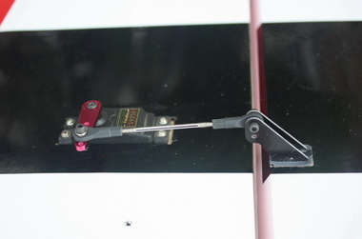
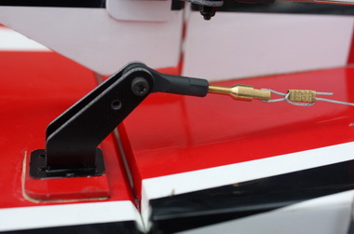

High quality 2.5mm ball links assemblys
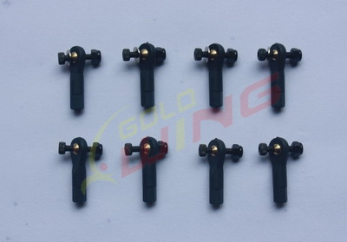

High-quality 3in nylon spinner included.
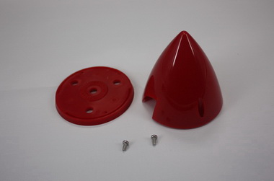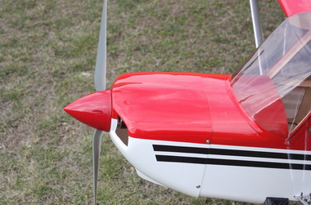

High-quality durable rubber wheels
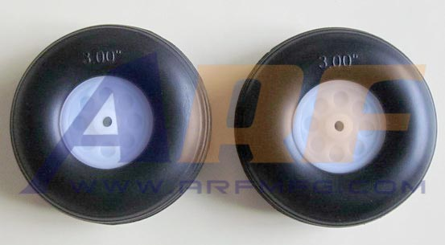

The air exit for the electric set up still needs to be inside the fuselage behind the rudder tray.
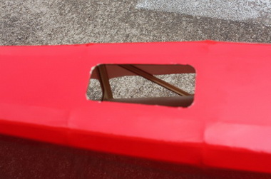

Servo extension safety connector clips
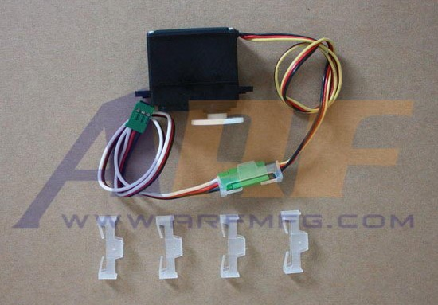

High performance cap head screws
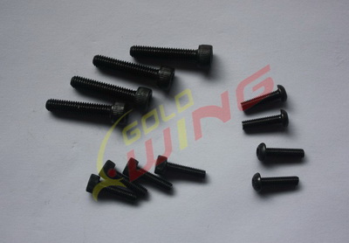

Airfoiled anodized 6061 Aluminum wing bracing struts
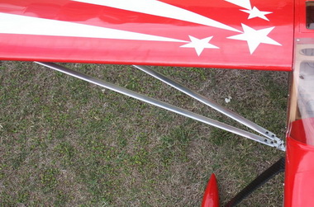
Two options for landing gear: Anodized 6061 Aluminum or Carbon fiber
Anodized 6061 Aluminum landing gear
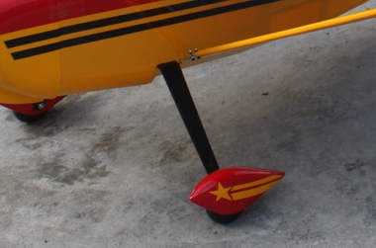

Carbon fiber landing gear
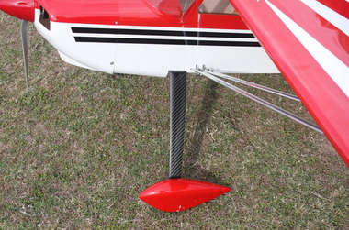

Carbon fiber wing tube
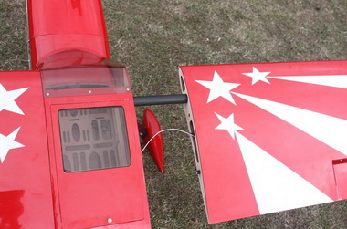

Carbon fiber tail wheel assembly
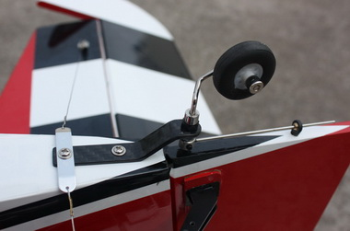
Scheme A white/ red / black
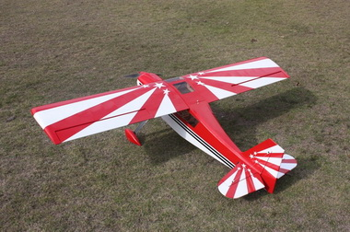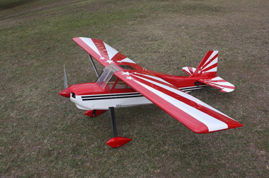
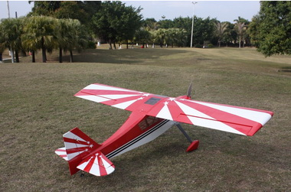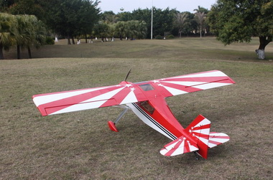
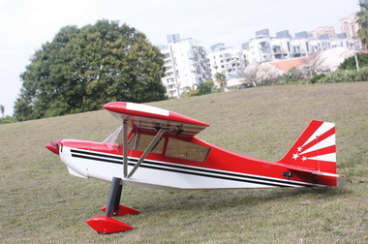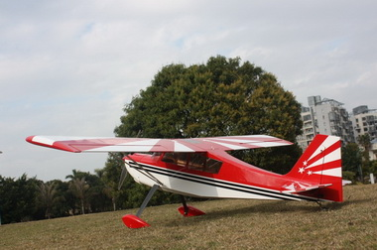
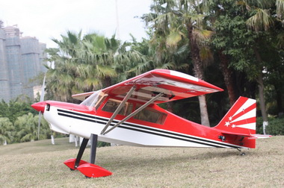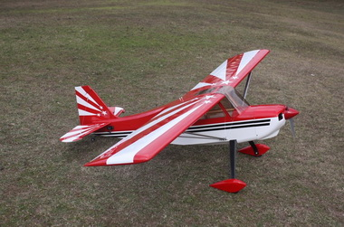

Scheme B blue /white/ red
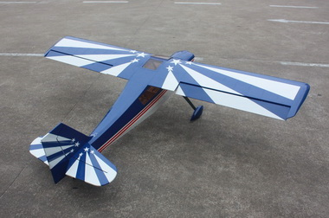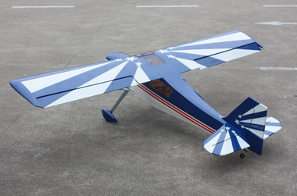
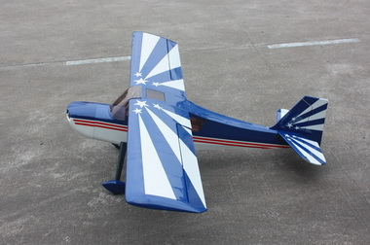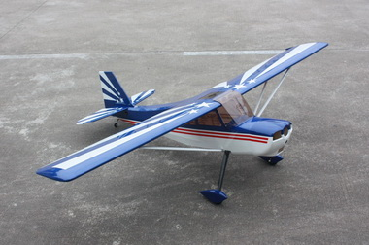
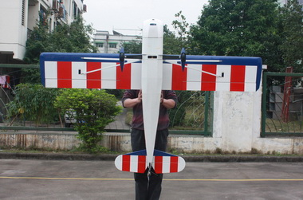

3in C.F Spinner （Not include）
